|  |  |
| --- | --- |
| logo png.png | **AAA COLLEGE OF ENGINEERING & TECHNOLOGY**  **Accredited by NAAC with Grade ‘A’,**  **Accredited by NBA ( CSE, EEE, ECE& MECH)**  **Approved by AICTE, New Delhi & Affiliated to Anna University, Chennai**  **Amathur, Sivakasi - 626 005.**  **Department of Electronics and Communication Engineering** |

1. **NOR gate using CMOS in LTSpice**

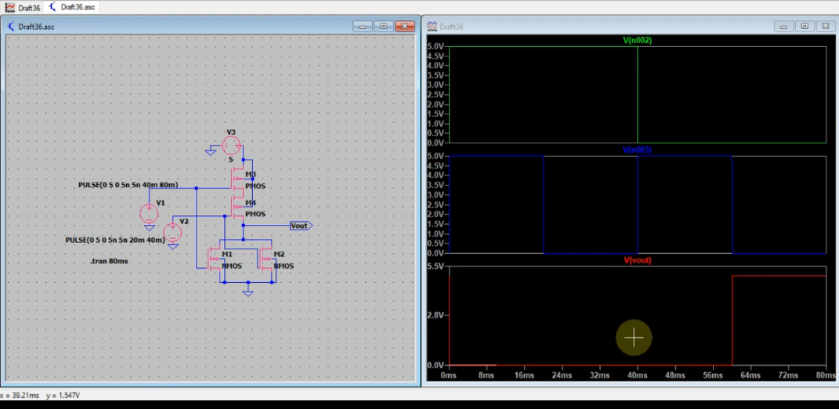

**2.NAND using CMOS in LTSpice**

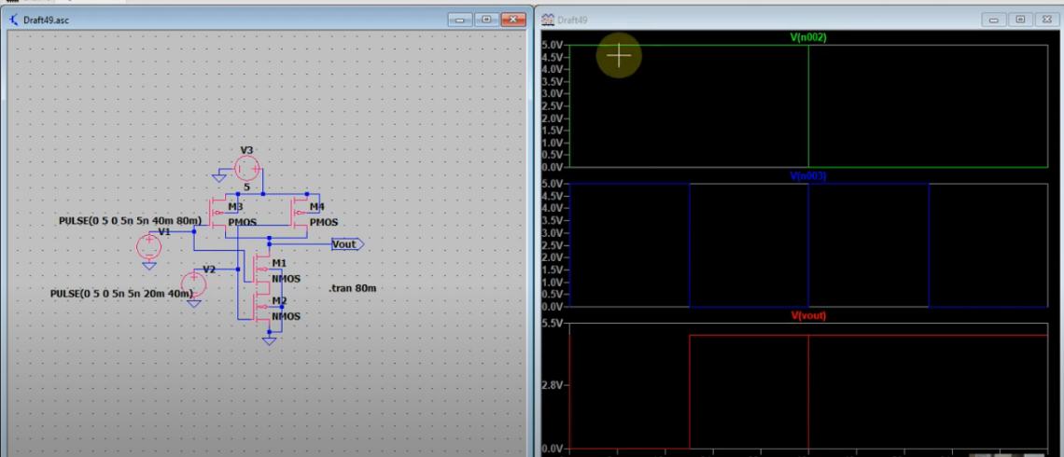

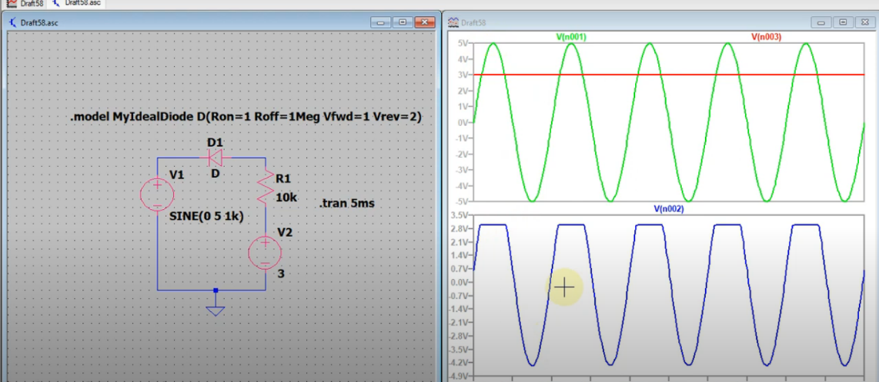**3.Clipper Circuit simulation in LTspice**

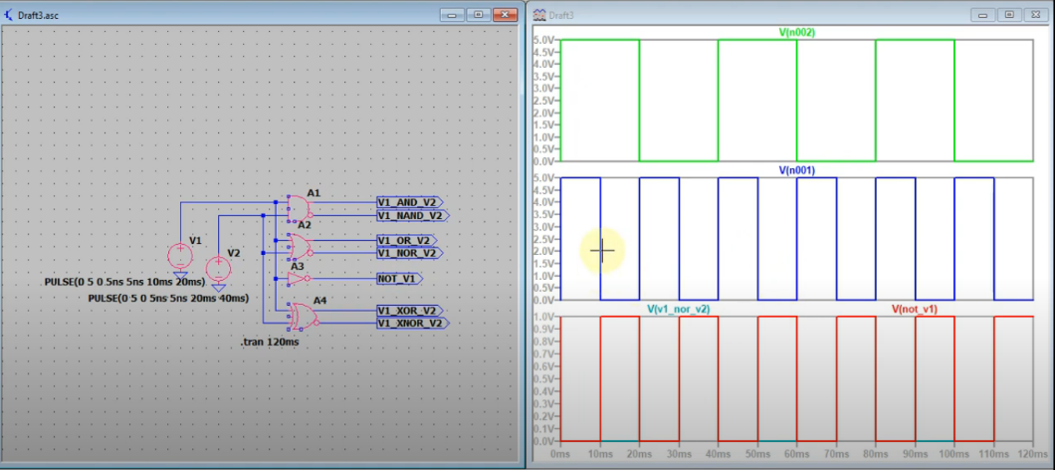**4.Basic 2-Input Logic Gates simulation in LTSpice**

**5.Half Adder simulation in LTSpice**

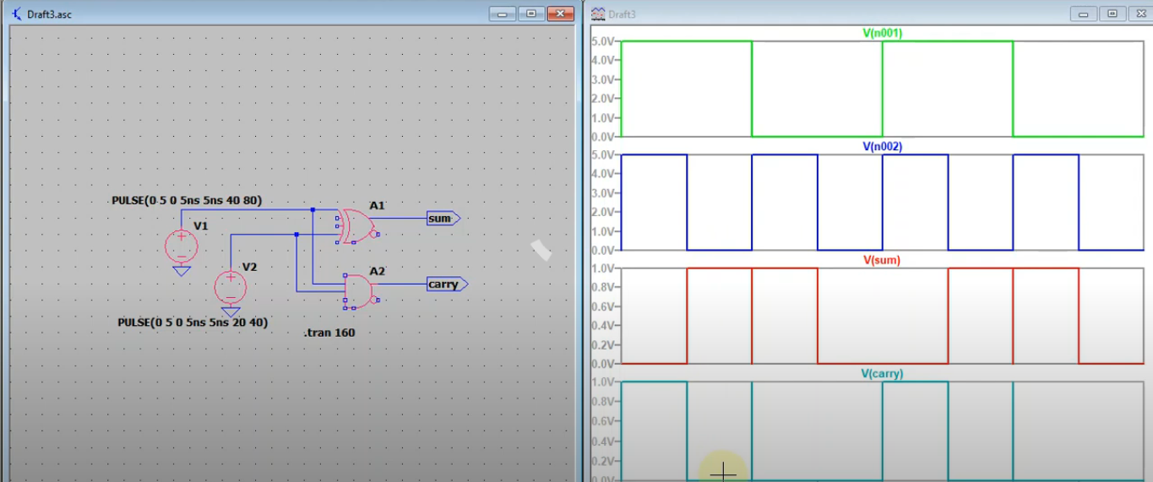

**6.2:1 MUX Simulation in LTspice**

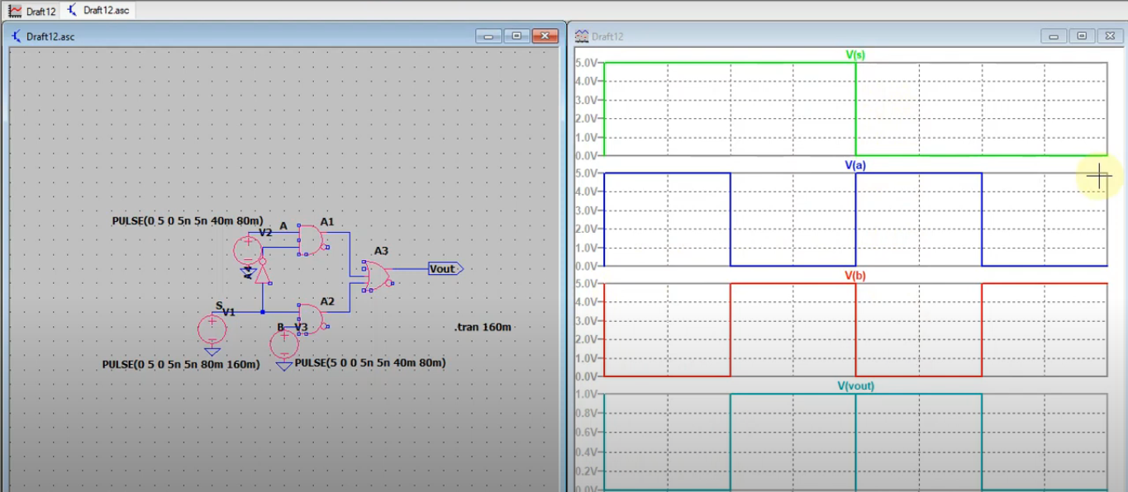

**7.LTspice Simulation of D Flip-flop using NAND gates**

